A Project Report
On
Rescue Route
submitted for partial fulfillment of the requirements
for the award of the degree of
Bachelor of Technology
in
Computer Science
Submitted by
Kashish Gupta(2000290120084)
Khushi Vaish(2000290120086)
Nikita Sharma(2000290120101)
Under supervision of
Prof. Ms. Akanksha

KIET Group of Institutions, Ghaziabad
Dr. A.P.J. Abdul Kalam Technical University, Lucknow,May, 2024
DECLARATION
We hereby declare that this submission is our own work and that, to the best of our knowledge and belief, it contains no material previously published or written by another person nor material which to a substantial extent has been accepted for the award of any other degree or diploma of the university or other institute of higher learning, except where due acknowledgment has been made in the text.

Signature
Name:- Kashish Gupta
Khushi Vaish
Nikita Sharma
Roll No.:- 2000290120084
2000290120085
2000290120101
Date:- 05/03/2024

CERTIFICATE

This is to certify that Project Report entitled “Rescue Route” which is submitted by Khushi Vaish in partial fulfillment of the requirement for the award of degree B. Tech. in Department of Computer Science of Dr. A.P.J. Abdul Kalam Technical University, Lucknow is a record of the candidates own work carried out by them under my supervision. The matter embodied in this report is original and has not been submitted for the award of any other degree.
.

Date: 05/03/2024 Supervisor
Name
(Designation)

ACKNOWLEDGEMENT

It gives us a great sense of pleasure to present the report of the B. Tech Project undertaken during B. Tech. Final Year. We owe special debt of gratitude to Professor (Name of Guide), Department of Computer Science, KIET, Ghaziabad, for his/her constant support and guidance throughout the course of our work. His/Her sincerity, thoroughness and perseverance have been a constant source of inspiration for us. It is only his cognizant efforts that our endeavors have seen light of the day.
We also take the opportunity to acknowledge the contribution of Dr. Pradeep Kumar Singh, Head of the Department of Computer Science, KIET, Ghaziabad, for his full support and assistance during the development of the project. We also do not like to miss the opportunity to acknowledge the contribution of all the faculty members of the department for their kind assistance and cooperation during the development of our project.
Last but not the least, we acknowledge our friends for their contribution in the completion of the project.
Date :
Signature: Signature:
Name : Name :
Roll No.: Roll No.:

ABSTRACT

In today’s world we have been facing problem due to increasing traffic on roads. This causes a lot of waste of time and increases stress level. As many emergency vehicles are also stuck in traffic for hours leads to losing life of people. So, this requires development of a system to handle traffic in a smart way by automatically adjusting its timing based on traffic density provide passage for ambulances using RCNN(Region-based Convolutional Neural Network), webcam, NodeMCU controller, LEDs. The core idea revolves around traffic management through the assessment of traffic volume on each side of the road, with the aim of implementing smart traffic signal control based on this density information. The webcam captures images of the vehicles on the road and send images to the NodeMCU microcontroller and then we apply RCNN algorithm and OpenCV to detect and count number of vehicles on the lane and set traffic timing accordingly. If ambulance is detected traffic light turns green on that side and other side are turn red to provide passage for emergency vehicles.

TABLE OF CONTENTS | Page No.
DECLARATION……………………………………………………………………. | ii
CERTIFICATE……………………………………………………………………… | iii
ACKNOWLEDGEMENTS…………………………………………………………. | iv
ABSTRACT………………………………………………………………………..... | v
LIST OF FIGURES…………………………………………………………………. | ix
LIST OF TABLES…………………………………………………………………… | xi
LIST OF ABBREVIATIONS………………………………………………………. | xii
CHAPTER 1 INTRODUCTION PAGE NO.
1.1 INTRODUCTION TO PROJECT
1.2 PROJECT CATEGORY(INTERNET BASED, APPLICATION OR SYSTEM DEVELOPMENT, RESEARCH BASED ,INDUSTRY AUTOMATION, NETWORK OR SYSTEM ADMINISTRATION)
1.3 OBJECTIVES
1.4 PROBLEM FORMULATION
1.5 PROPOSED SYSTEM
1.6 UNIQUE FEATURES OF THE SYSTEM

CHAPTER 2. REQUIREMENT ANALYSIS AND SYSTEM SPECIFICATION
2.1 FEASIBILITY STUDY (TECHNICAL, ECONOMICAL, OPERATIONAL)
2.2 SOFTWARE REQUIREMENT SPECIFICATION DOCUMENT WHICH MUST INCLUDE THE FOLLOWING:
(DATA REQUIREMENT, FUNCTIONAL REQUIREMENT, PERFORMANCE REQUIREMENT
, MAINTAINABILITY REQUIREMENT, SECURITY REQUIREMENT)
2.3 SDLC MODEL TO BE USED

CHAPTER 3. SYSTEM DESIGN
3.1 DETAIL DESIGN
3.2 SYSTEM DESIGN USING DFD LEVEL 0 AND LEVEL 1
3.3 USE CASE DIAGRAM
3.4 DATABASE DESIGN
3.4.1 ER DIAGRAMS

CHAPTER 4. IMPLEMENTATION, TESTING, AND MAINTENANCE
4.1 INTRODUCTION TO LANGUAGES,TOOLS AND TECHNOLOGIES USED FOR IMPLEMENTATION
4.2 TESTING TECHNIQUES AND TEST CASES USED

CHAPTER 5. RESULTS AND DISCUSSIONS
5.1 USER INTERFACE REPRESENTATION (OF RESPECTIVE PROJECT)
5.1.1 BRIEF DESCRIPTION OF VARIOUS MODULES OF THE SYSTEM
5.2 SNAPSHOTS OF SYSTEM WITH BRIEF DETAIL OF EACH
5.3 BACK ENDS REPRESENTATION (DATABASE TO BE USED )
5.3.1 SNAPSHOTS OF DATABASE TABLES WITH BRIEF DESCRIPTION
CHAPTER 6. CONCLUSION AND FUTURE SCOPE

REFERENCES( REFERENCES SHOULD BE IN IEEE STANDARD)

CHAPTER 1
INTRODUCTION
  - INTRODUCTION TO PROJECT
One of the pressing issues exacerbated by the world's growing population and the rapid increase in the number of vehicles is traffic congestion. In countries like India, the rate of expanding road infrastructure lags far behind the rate of vehicle growth [1]. Traffic jams give rise to numerous critical problems that have a direct impact on people's daily lives and, in some cases, even lead to loss of life [2]. For instance, when an emergency vehicle such as an ambulance is transporting a critically ill patient, being trapped in a heavy traffic jam significantly reduces the chances of the patient reaching the hospital in a timely manner. Therefore, it is imperative to develop an intelligent traffic management system that can effectively regulate traffic to prevent accidents, collisions, and traffic gridlocks, with a special focus on ensuring the swift passage of emergency vehicles like ambulances[3]. These challenges can be mitigated through the application of emerging technologies, specifically Machine Learning (ML). By establishing connections between a range of software packages and hardware devices, whether through wireless or wired means, a system can be created to efficiently regulate traffic. This system operates by automatically adjusting signal timings in accordance with traffic density and also facilitates the unobstructed passage of emergency vehicles, such as ambulances, utilizing RCNN (Regionbased Convolutional Neural Network), webcams, NodeMCU controllers, and LEDs.

  - PROJECT CATEGORY(INTERNET BASED, APPLICATION OR SYSTEM DEVELOPMENT, RESEARCH BASED ,INDUSTRY AUTOMATION, NETWORK OR SYSTEM ADMINISTRATION)
Industry automation refers to the use of control systems, such as computers or robots, and information technologies for handling different processes and machinery in an industry to replace human involvement. In the context of the smart traffic management system you are developing, industry automation plays a crucial role in optimizing traffic flow and providing efficient passage for emergency vehicles.

The system utilizes various technologies, including RCNN (Region-based Convolutional Neural Network), webcam, NodeMCU controller, LEDs, and OpenCV, to automate traffic signal control based on real-time traffic density information. This automation reduces the need for manual intervention in adjusting traffic signal timings, making the system more efficient and responsive to changing traffic conditions.

By automating the detection and counting of vehicles on each lane using RCNN and OpenCV, the system can accurately assess traffic volume and adjust traffic signal timings accordingly. This not only improves traffic flow but also reduces congestion and travel time for commuters.

Moreover, the system's ability to detect and prioritize emergency vehicles, such as ambulances, by automatically turning traffic lights green on their route, demonstrates how industry automation can significantly improve emergency response times and potentially save lives.

Overall, the smart traffic management system exemplifies how industry automation can be applied to solve real-world problems, making processes more efficient, reliable, and responsive to changing conditions.
1.3 OBJECTIVES
- Optimize Traffic Flow: Develop a system that adapts traffic signal timings based on real-time traffic density data to alleviate congestion, reduce travel times, and enhance overall transportation efficiency.
- Increase Ambulance Response Efficiency: Establish a priority mechanism to grant ambulances a red-light-free pathway, ensuring swift response to emergencies and enhancing public safety.
- Reduce Environmental Impact: By minimizing traffic congestion and idling, contribute to lower emissions and reduced environmental pollution, thereby promoting a healthier urban environment.
- Enhance Public Safety: Improve the safety of the public by expediting ambulance responses and minimizing the risk of delays during critical medical emergencies.
- Improve Urban Transportation Infrastructure: Implement an innovative solution that enhances the functionality of urban traffic management systems, ultimately benefiting the quality of life and transportation experience for residents.

  - PROBLEM FORMULATION
The problem formulation for your project could be stated as follows:
"Increasing traffic congestion on roads leads to significant time wastage and stress for commuters, while also posing challenges for emergency vehicles trying to navigate through traffic. This project aims to develop a smart traffic management system that uses RCNN (Region-based Convolutional Neural Network), webcam, NodeMCU controller, LEDs, and OpenCV to automate traffic signal control based on real-time traffic density information. The system will detect and count vehicles on each lane using RCNN and OpenCV, adjust traffic signal timings accordingly to optimize traffic flow, and provide a green light for emergency vehicles detected in the vicinity to ensure their timely passage. By addressing these issues, the system aims to improve overall traffic efficiency and emergency response times, ultimately enhancing road safety and reducing travel time for commuters."

  - PROPOSED SYSTEM
The goal of traffic management is to minimize other effects of the current road network while maximizing efficiency of the traffic structure without any issues. The system is improving upon the shortcomings of earlier traffic management frameworks. The mechanism uses automobiles' traffic density as determined by camera input, which is separated from pictures of cars. We have issues in the modern world because of the rise in traffic on the roads. This raises stress levels and results in significant time waste. Many emergency vehicles get caught in traffic for hours at a time, which results in fatalities. This calls for the creation of a system that uses RCNNs (Region based Convolutional Neural Networks), webcams, NodeMCU controllers, and LEDs to handle traffic in an intelligent manner by automatically adjusting its timing based on traffic density and provide passage for ambulances . The NodeMCU microcontroller receives images from the webcam that show the cars on the road. We then use the RCNN algorithm and OpenCV to count the number of cars in each lane and adjust traffic timing accordingly. If an ambulance is seen in the road. When an ambulance is spotted, the traffic light on that side turns green, and the other side turns red to allow emergency vehicles to pass.
1.6 UNIQUE FEATURES OF THE SYSTEM
The smart traffic management system you are developing has several unique features that set it apart from traditional traffic management systems:
Real-time Traffic Density Assessment: The system uses RCNN and OpenCV to detect and count vehicles on each lane in real-time, allowing for dynamic adjustment of traffic signal timings based on current traffic conditions.
Automatic Adjustment of Traffic Signal Timings: By automatically adjusting traffic signal timings based on traffic density, the system can optimize traffic flow and reduce congestion, leading to shorter travel times for commuters.
Emergency Vehicle Priority: The system can detect emergency vehicles, such as ambulances, and provide them with a green light to ensure their timely passage through traffic, potentially saving lives in emergency situations.
Integration of Multiple Technologies: The system integrates various technologies, including RCNN, webcam, NodeMCU controller, LEDs, and OpenCV, to create a comprehensive and efficient traffic management solution.
Smart and Adaptive Traffic Control: The system's ability to adapt to changing traffic conditions in real-time makes it a more efficient and effective solution compared to traditional traffic management systems
CHAPTER 2.
REQUIREMENT ANALYSIS AND SYSTEM SPECIFICATION

2.1 FEASIBILITY STUDY (TECHNICAL, ECONOMICAL, OPERATIONAL)
The feasibility study for the smart traffic management system evaluates its technical, economical, and operational aspects to determine its viability and potential success.

Technical Feasibility:
Hardware Compatibility: Ensure that the system components (e.g., webcam, NodeMCU controller) are compatible and capable of performing the required tasks.
Software Compatibility: Verify that the software components (e.g., OpenCV, TensorFlow) can be integrated and function as intended.
Scalability: Determine if the system can scale to handle increased traffic and additional lanes or intersections.
Reliability: Assess the system's reliability in accurately detecting vehicles, adjusting traffic signals, and providing priority passage for emergency vehicles.

Economical Feasibility:
Cost-Benefit Analysis: Evaluate the costs associated with developing, implementing, and maintaining the system against the potential benefits, such as reduced traffic congestion and improved emergency vehicle response times.
Return on Investment (ROI): Determine if the system's benefits outweigh its costs over the long term.
Budget Considerations: Ensure that the project fits within the allocated budget and financial constraints.

Operational Feasibility:
User Acceptance: Assess the willingness of users (e.g., traffic authorities, commuters) to adopt and use the system.
Training Requirements: Determine the training needs for operating and maintaining the system.
Legal and Regulatory Compliance: Ensure that the system complies with relevant laws and regulations governing traffic management and data privacy.

2.2 SOFTWARE REQUIREMENT SPECIFICATION DOCUMENT WHICH MUST INCLUDE THE FOLLOWING:
(DATA REQUIREMENT, FUNCTIONAL REQUIREMENT, PERFORMANCE REQUIREMENT)
The Software Requirement Specification (SRS) document for the Smart Traffic Management System is a comprehensive outline of the system's requirements and functionalities. It begins with an introduction that defines the purpose and scope of the document, along with key definitions and abbreviations. The system overview provides a high-level description of the system, including its goals, objectives, and major features.

The data requirements section specifies the sources, formats, storage, and access requirements for the system's data. Functional requirements describe the system's features, use cases, user interactions, input and output requirements, and error handling mechanisms. Performance requirements detail the system's response times, throughput, reliability, and scalability expectations.

Design constraints outline any limitations imposed by hardware, software, compatibility, and security considerations. Quality attributes cover usability, reliability, maintainability, security, and portability requirements. Other requirements include documentation, training, legal, regulatory, testing, and maintenance needs.

2.3 SDLC MODEL TO BE USED
The Smart Traffic Management System will follow the Agile software development methodology. Agile is chosen for its iterative and incremental approach, allowing for flexibility and adaptability to changing requirements. This model will enable the development team to deliver a functional product quickly and incrementally, while also incorporating feedback from stakeholders throughout the development process. The Agile methodology's emphasis on collaboration and customer involvement aligns well with the dynamic nature of the project, ensuring that the final product meets the needs and expectations of its users.

CHAPTER 3.
SYSTEM DESIGN

3.1 DETAIL DESIGN
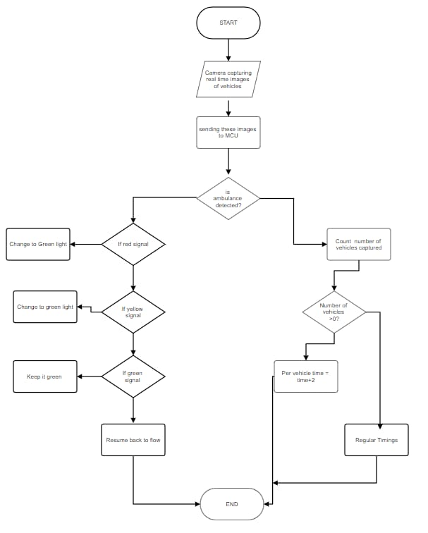
3.2 SYSTEM DESIGN USING DFD LEVEL 0 AND LEVEL 1
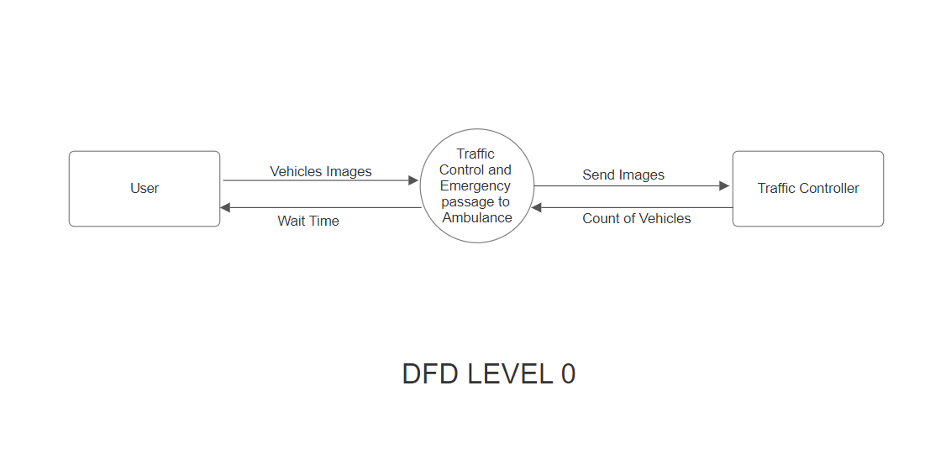
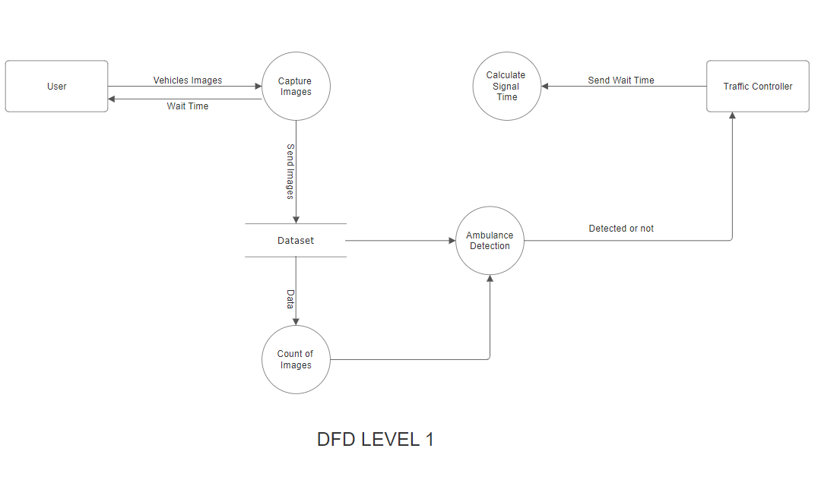
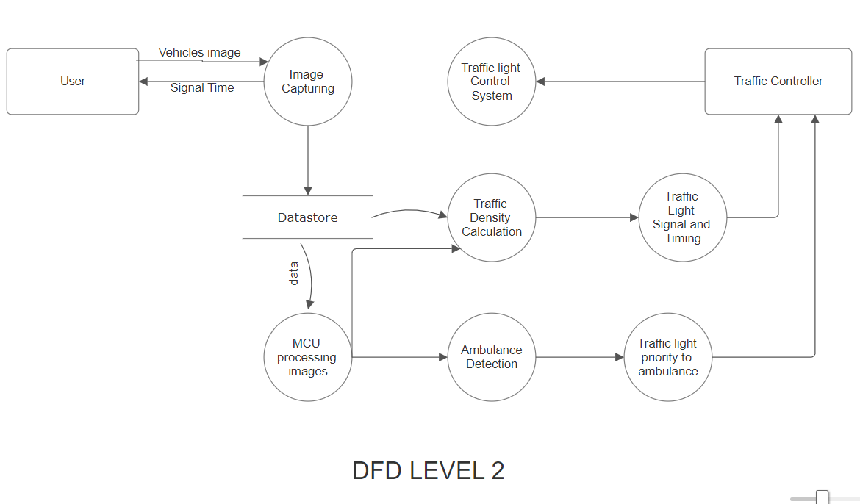

3.3 USE CASE DIAGRAM
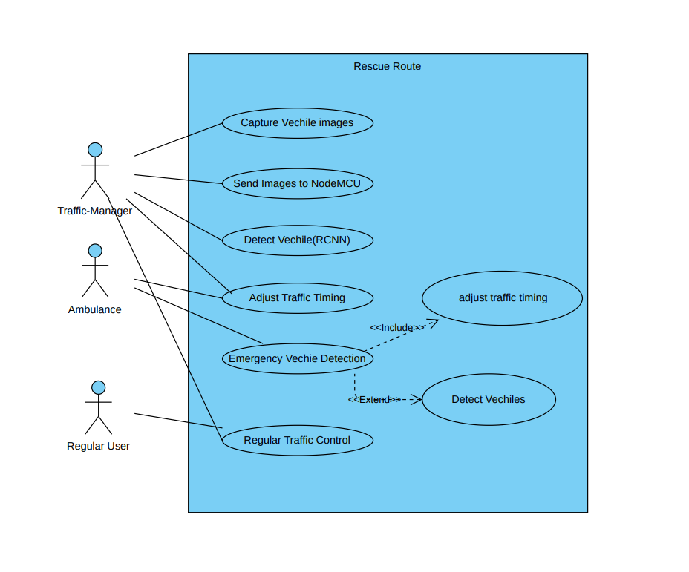

3.4.1 ER DIAGRAMS

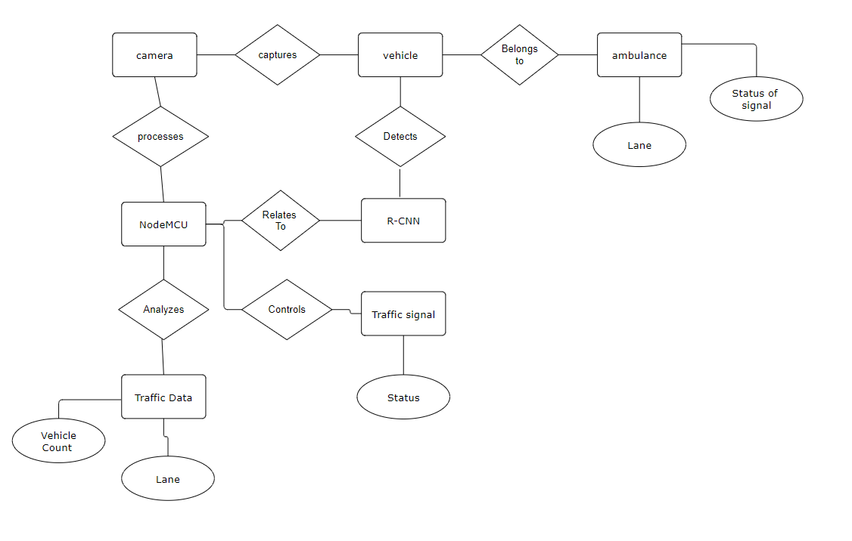

CHAPTER 4.
IMPLEMENTATION, TESTING, AND MAINTENANCE

4.1 INTRODUCTION TO LANGUAGES,TOOLS AND TECHNOLOGIES USED FOR IMPLEMENTATION
The smart traffic management system utilizes a combination of languages, tools, and technologies to achieve its goals:
Programming Languages:
Python: Used for implementing the RCNN (Region-based Convolutional Neural Network) algorithm and for image processing tasks using OpenCV.
C/C++: Used for programming the NodeMCU controller to control the traffic signals and interface with the webcam and LEDs.

Tools and Libraries:
OpenCV: An open-source computer vision and machine learning software library used for image processing tasks such as vehicle detection and counting.
TensorFlow or PyTorch: Deep learning frameworks that can be used to implement the RCNN algorithm for vehicle detection.
Arduino IDE: Used for programming the NodeMCU controller, which is based on the ESP8266 chip, to control the traffic signals and interface with other components.

Technologies:
RCNN (Region-based Convolutional Neural Network): A deep learning algorithm used for object detection, in this case, for detecting vehicles in images captured by the webcam.
NodeMCU Controller: A low-cost open-source IoT platform based on the ESP8266 Wi-Fi module, used for controlling the traffic signals and communicating with other components of the system.
Webcam: Used for capturing images of the traffic flow, which are then processed to detect vehicles and assess traffic density.
LEDs: Used as the traffic signals to control the flow of vehicles based on the decisions made by the system.

Networking:
Wi-Fi: The NodeMCU controller communicates with the webcam and other components over a Wi-Fi network, enabling real-time data transfer and control.

Software Development:
Integrated Development Environments (IDEs): Used for writing and debugging code, such as PyCharm or Visual Studio Code for Python, and Arduino IDE for programming the NodeMCU controller.

4.2 TESTING TECHNIQUES AND TEST CASES USED
Testing techniques and test cases are crucial for ensuring the effectiveness and reliability of the smart traffic management system. Here are some testing techniques and test cases that could be used:

Functional Testing:
Test Case: Verify that the system can detect vehicles in images captured by the webcam.
Test Case: Ensure that the traffic lights change according to the detected traffic density.

Performance Testing:
Test Case: Evaluate the system's response time in detecting vehicles and adjusting traffic lights.
Test Case: Measure the system's ability to handle a high volume of traffic data.

Integration Testing:
Test Case: Verify that the NodeMCU controller can communicate with the webcam and other components.
Test Case: Ensure that the RCNN algorithm integrates correctly with the overall system.

Usability Testing:
Test Case: Evaluate the system's user interface for ease of use and understandability.

Reliability Testing:
Test Case: Test the system's ability to operate consistently over an extended period.

Security Testing:
Test Case: Ensure that the system is protected against unauthorized access and data breaches.
Regression Testing:
Test Case: Verify that new updates or changes to the system do not adversely affect existing functionality.
CHAPTER 5.
RESULTS AND DISCUSSIONS
5.1 USER INTERFACE REPRESENTATION (OF RESPECTIVE PROJECT)
The user interface for the smart traffic management system is designed to provide users with a comprehensive and intuitive way to monitor and manage traffic effectively. At the core of the interface is a real-time traffic overview, displaying the current traffic conditions on each lane with color-coded indicators for low, medium, and high traffic density. This information is crucial for users to understand the current state of traffic and allows the system to automatically adjust traffic signal timings based on traffic density to optimize traffic flow. In addition to automatic adjustments, the interface also provides manual control options, allowing users to manually adjust traffic signal timings or override the system to prioritize emergency vehicles. The interface also includes settings for configuring network settings and notifications for system alerts. A live feed from the webcam provides visual confirmation of the traffic conditions, while a system status section displays visual indicators for the system's status and any error messages or alerts. Overall, the user interface is designed to be user-friendly and informative, providing users with the tools they need to effectively manage traffic and prioritize emergency vehicles.

5.1.1 BRIEF DESCRIPTION OF VARIOUS MODULES OF THE SYSTEM
The smart traffic management system comprises several interdependent modules, each serving a distinct purpose to automate traffic control and enhance road safety. The Traffic Monitoring Module employs a webcam to capture real-time traffic images, which are then processed using OpenCV for vehicle detection and traffic density calculation. The RCNN (Region-based Convolutional Neural Network) Module further enhances vehicle detection accuracy through deep learning techniques. The Traffic Signal Control Module utilizes data from the Traffic Monitoring Module to adjust traffic signal timings dynamically, optimizing traffic flow. Simultaneously, the Emergency Vehicle Detection Module identifies emergency vehicles, such as ambulances, and triggers the Traffic Signal Control Module to provide them with priority passage. The User Interface Module provides a graphical interface for users to monitor traffic conditions, traffic signal status, and emergency vehicle alerts, allowing for manual control when necessary. The Networking Module facilitates communication between modules over a Wi-Fi network, ensuring seamless data exchange. Lastly, the System Management Module oversees system operations, logging, and error handling, ensuring the system operates efficiently and reliably. Together, these modules form a comprehensive smart traffic management system that enhances traffic efficiency and safety.

5.2 SNAPSHOTS OF SYSTEM WITH BRIEF DETAIL OF EACH
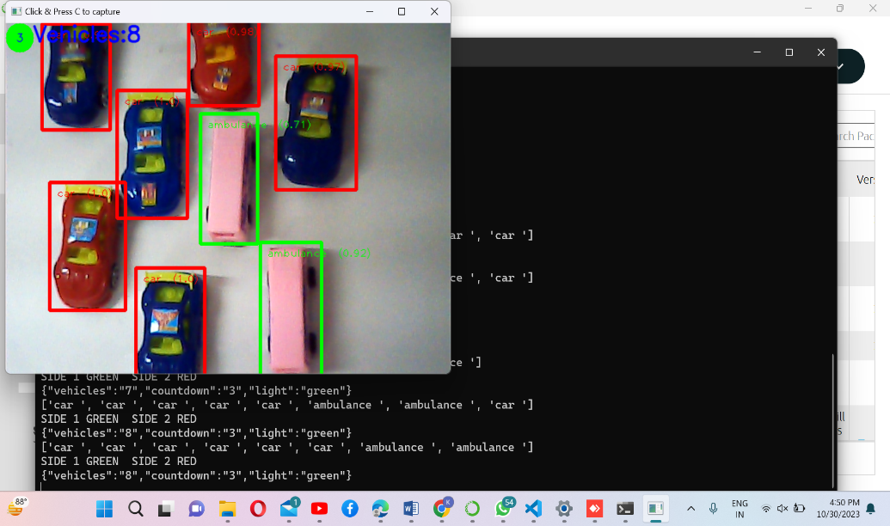
Following are the components used:
- NodeMCU Controller : There are open source prototyping board designs available for the NodeMCU firmware. "Node" and "MCU" (micro-controller unit) are combined to form the term "NodeMCU". The firmware itself is referred to as "NodeMCU" strictly speaking, not the related development kits.The designs for the prototyping board and firmware are both available for free.The scripting language Lua is used by the firmware. The firmware was developed using the Espressif Non-OS SDK for ESP8266 and is based on the eLua project. Numerous open source projects are used, including SPIFFS and lua-cjson[9].10] Owing to limited resources, users must choose the modules that are pertinent to their project and create a firmware that meets their requirements. Additionally, support for the 32-bit ESP32 has been added.
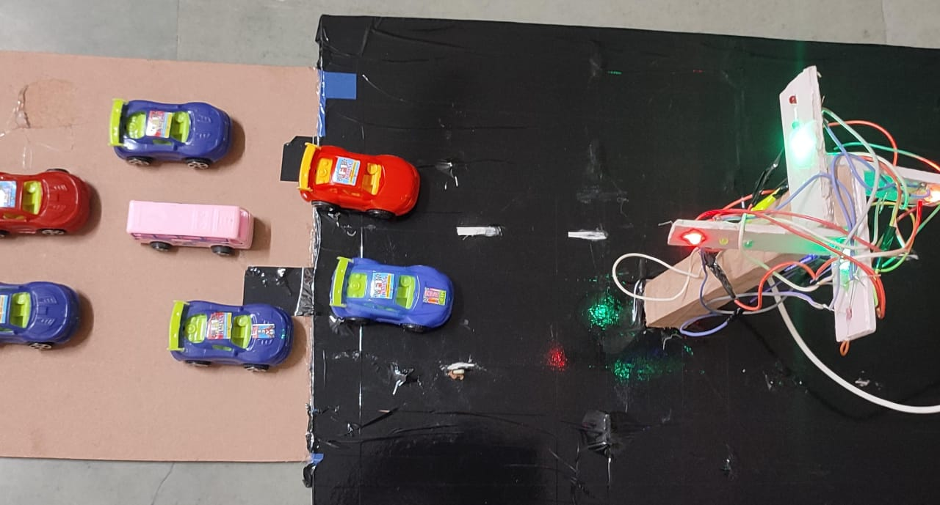
B. LEDs(Light emitting Diode)
When current passes through a light-emitting diode (LED), a semiconductor device, light is released. Photons are released as a result of the semiconductor's electrons and electron holes recombining. The energy needed for electrons to cross the semiconductor's band gap determines the color of the light, which is correlated with photon energy.(5) Using multiple semiconductors or covering the semiconductor device with a layer of light-emitting phosphor allows for the production of white light.

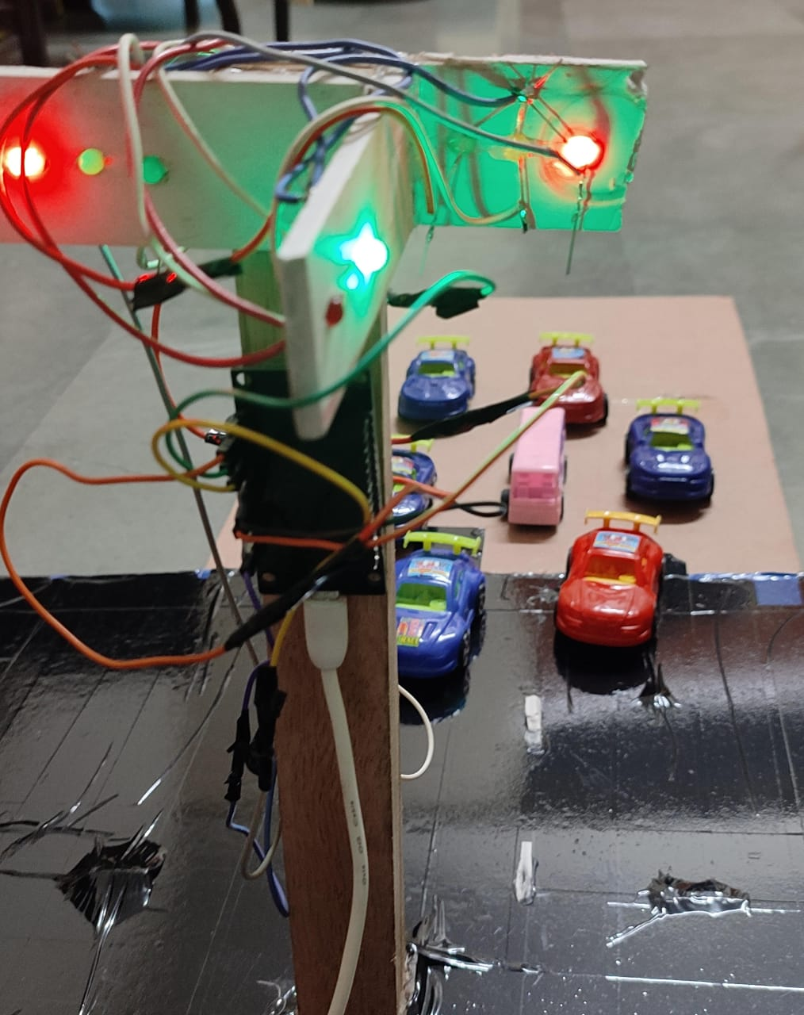

C. RCNN(Region-Based Convolutional Neural Network)
In computer vision, region-based convolutional neural networks, or RCNNs, are essential object detection algorithms. The task is split into two phases: producing region suggestions in an image where objects could be present, and then categorizing these regions and fine-tuning their borders. Using selective search, RCNN creates region proposals, from which a convolutional neural network that has been trained to extract features is used. After that, it uses support vector machines to categorize objects inside these regions and fine-tunes the bounding box coordinates for accurate localization. While RCNN was revolutionary, later models such as Fast R-CNN and Faster R-CNN enhanced its performance by combining deep learning with region proposal techniques, resulting in object detection systems that operate more quickly and accurately in real-world scenarios.
RCNN, or Region-based Convolutional Neural Network, is a deep learning approach employed for the detection of vehicles in images and videos. The process involves data collection with annotated vehicle bounding boxes, dataset preprocessing, selecting an RCNN model like Faster R-CNN, training the model on the vehicle dataset, using a Region Proposal Network for generating potential object regions, classifying and refining these regions, applying post-processing for false positive reduction, evaluating model performance, and ultimately using the trained model for vehicle detection in new images or videos, making it a valuable tool for applications like autonomous driving and traffic monitoring.

CHAPTER 6.
CONCLUSION AND FUTURE SCOPE
The system under consideration here effectively oversees traffic in real-time, leading to a reduction in accident rates and the preservation of valuable time spent waiting at traffic signals. This foundational approach paves the way for automation in traffic signal. Comparison Table control systems. Granting priority to ambulances equipped with emergency tags ensures quicker hospitalization for patients, ultimately contributing to saving lives. This novel approach offers several advantages, including the utilization of image processing instead of sensors, cost-effectiveness, simple installation, and a balance of both accuracy and speed. The authors created this project as a proof of concept because it is a final year project and because of constraints. Since the active webcam range is only about 10 meters, future research can concentrate on utilizing cloud computing to test it at various distances between the ambulance and oncoming traffic, as well as in real traffic lights, as well as for various ambulance speeds. This model will provide a cost effective and efficient way for controlling traffic density and proving way for ambulances. A comparison is shown between the existing system and our proposed system.

REFERENCES
[1] Varsha Srinivasan et al 2018 IOP Conf. Ser.: Mater. Sci. Eng. 402 012015
[2] Papageorgiou M., Diakaki C., Dinopoulou V., Kotsialos, A.,“Review of road traffic control strategies”, Proceedings of IEEE, Vol. 91, Issue 12, pp. 2043-2067, November 2004.
[3] Georgios Vigos, Markos Papageorgioua, Yibing Wangb, “Real-time estimation of vehicle-count within signalized links”, Journal of Transportation Research Part C: Emerging Technologies, Volume 16, Issue 1, pp.18–35, February 2008.
[4] Abbas, Naeem, Muhammad Tayyab, and M. Tahir Qadri. "Real time traffic density count using image processing." International Journal of Computer Applications 83.9 (2013): 16-19.
[5] Jadhav, Prashant, et al. "Smart traffic control system using image processing." International Research Journal of Engineering and Technology (IRJET) 3.3 (2016): 2395-0056.
[6] D. M. . Varadharaj, “Density Based Traffic Control System with Smart Sensing Of Emergency Vehicles”, converter, pp. 01 - 07, Dec. 2019.
[7] M. F. Chowdhury, M. Ryad Ahmed Biplob and J. Uddin, "Real Time Traffic Density Measurement using Computer Vision and Dynamic Traffic Control," 2018 Joint 7th International Conference on Informatics, Electronics & Vision (ICIEV) and 2018 2nd International Conference on Imaging, Vision & Pattern Recognition (icIVPR), Kitakyushu, Japan, 2018, pp. 353-356
[8] H. Yuliandoko, M. D. Ayatullah and F. E. Purwita, "Automatic Vehicle Counting Using Raspberry pi and Background Subtractions Method in The Sidoarjo Toll Road," 2019 2nd International Conference of Computer and Informatics Engineering (IC2IE), Banyuwangi, Indonesia, 2019, pp. 83-86, doi: 10.1109/IC2IE47452.2019.8940899.
[9] Firdous, Anam, and Vandana Niranjan. "Smart density based traffic light system." 2020 8th International Conference on Reliability, Infocom Technologies and Optimization (Trends and Future Directions)(ICRITO). IEEE, 2020.
[10] Ni, Yuanzhi, et al. "Toward reliable and scalable internet of vehicles: Performance analysis and resource management." Proceedings of the IEEE 108.2 (2019): 324-340.
[11] Y. Ni, L. Cai, J. He et al., “Toward reliable and scalable internet of vehicles: performance analysis and resource management,” Proceedings of the IEEE, vol. 108, no. 2, pp.324–340, 2020.
[12] Pratishtha Gupta, G.N Purohit, Sweta Pandey, “Traffic Load Computation for Real Time Traffic Signal Control”, International Journal of Engineering and Advanced Technology, Vol. 2, Issue 4, April 2013
[13] Sabya sanchi kanojia, “Real –time Traffic light control and Congestion avoidance system”, International Journal of Engineering Research and Applications (IJERA), pp.925-929, Vol. 2, Issue 2,MarApr 2012.
[14] VismayPandit, JineshDoshi, Dhruv Mehta, AshayMhatre and AbhilashJanardhanǲSmart Traffic Control System Using Image Processingǳ International Journal of Emerging Trends & Technology in Computer Science (IJETTCS)Volume 3, Issue 1, January – February 2014 ISSN 2278-6856

LIST OF FIGURES

Figure No. | Description | Page No.
1.1 | Categorization of routing protocol | 2
2.1 | Three models | 9
3.1 | Resolving failed links in DSDV | 12

LIST OF TABLES

Table. No. | Description | Page No.
1.1 | General Simulation parameters | 22

LIST OF ABBREVIATIONS

NAM Network Animator

MANET Mobile Ad-hoc Network

DSDV Destination Sequence Distance Vector

DSR Dynamic Sequence Resource

AODV Ad-hoc On-Demand Vector

OSI Open System Interconnections

TCP/IP Transmission Control Protocol/Internet Protocol

Pdf Packet Drop Fraction

GSR Global State Routing

